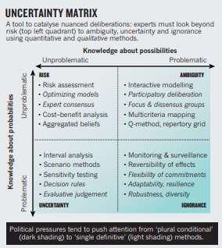Stirling Paper Summary

### Readers: Anna & Jonathan, DOLE: 23-4-2021

Narrow focus on risk is an inadequate response to incomplete knowledge because it leaves science advice vulnerable to social dynamics of groups and manipulation by politicians.

Thus, it is important to recognise uncertainty. Now there is a too big of a focus on risk, which assumes you know the possibilities and probabilities 🡪 move to plural and conditional expert advice to show reality better and be more democratically accountable.

Quantitative uncertainty can be addressed by showing the range of possible outcomes of (different) studies instead of one specific outcome.

Qualitative uncertainty can be addressed by letting go of the need to reach consensus amongst experts and instead show a measures array of specialist views with reasoning.

A problem remains: disagreement over the framing of possible options, contexts, benefits or harms. Ways to deal: participatory and deliberative procedures:

* Multicriteria mapping: scoring and weighting procedures to reveal the ways in which overall rankings depend on divergent ways of framing the possible options.
* Others: Interactive modelling, Scenario workshops, Q-methods, Dissensus methods

No definitive party that is right/wrong also improves cooperation.

Danger: locking-in: when one view has been accepted, it becomes more difficult over time to switch the direction of progress. Plural advice helps to avoid faulty one-track visions of progress.